Creating Local Repositories with Git and
Adding/Checking in Files SOP



Table of Contents

1. Creating Local Repositories with Git and Adding/Checking in Files 3
1.1 Description 3
1.2 Architecture Diagram 3
1.3 Lab Steps 4
1.4 Troubleshooting 4
1.5 Supporting References 4

Creating Local Repositories with Git and Adding/Checking in Files

Description
Git is a free and open source distributed version control system designed to handle everything from small to very large projects with speed and efficiency. Before writing any code, you need to create a CodeCommit repository, clone it locally, add a README.md file, commit the file, and push it to CodeCommit.

Architecture Diagram
The diagram below displays a visual representation of the application architecture:
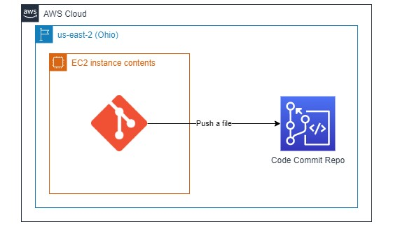

Lab Steps
Follow the steps outlined below to achieve the objective of this lab exercise:

- Create a CodeCommit Repository and copy the clone URL (HTTPS) for future use.
- Create an EC2 Instance (Amazon Linux 2) and SSH into it via Sessions Manager Option.
Note: Make sure the role CCL-EC2-Role is attached to the instance, only then can you select the Sessions Manager Option.
- Change user to super user or root user and change directory to ~
- Make sure Git is installed, if not install Git. Then perform the following configurations:
git config --global user.name “<Some Name>”
git config --global user.email “<some email”>
- Navigate to IAM > Users > Your UserName > Security Credentials > HTTPS Git Credentials for CodeCommit. Here generate credentials and save them.

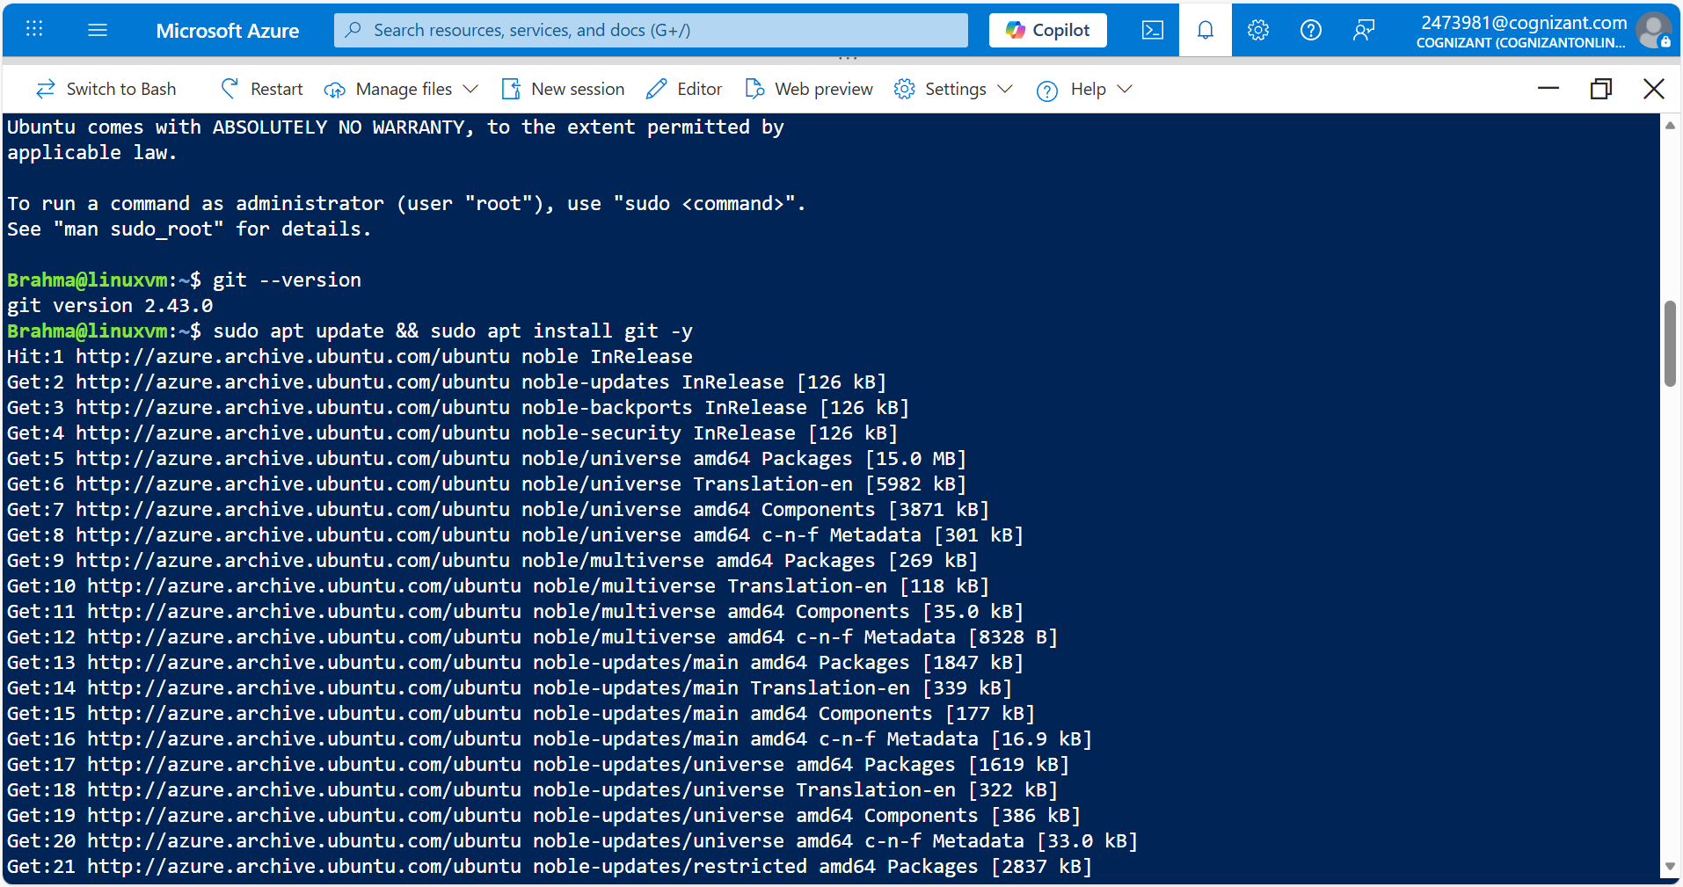
- Clone the created repo by pasting the copied URL from Step 1.

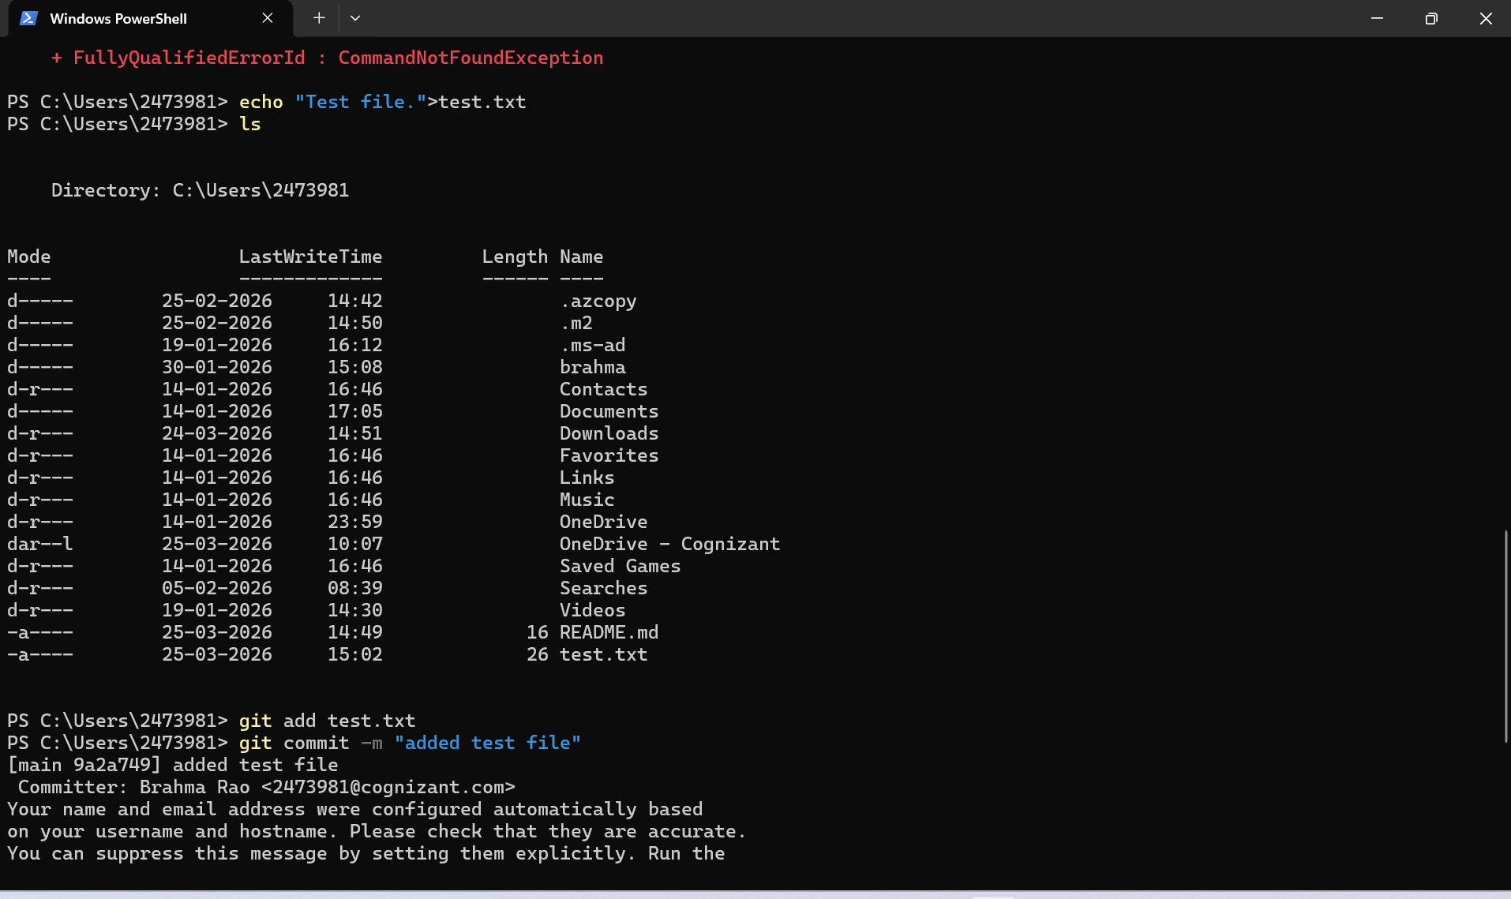
- Change directory to the created repo
- Create a new file with some content and perform the following steps:
git add <filename>
git commit –m “<Some commit message>”
git push origin master
- Go to the created repo and check if the pushed file is available there.
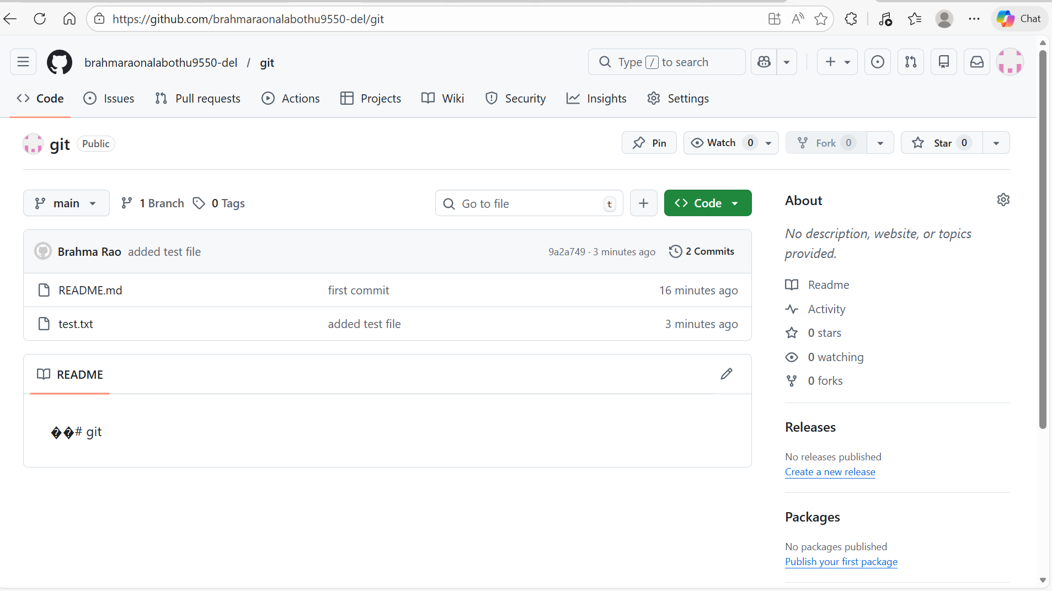

Troubleshooting
S. No | Problem | Solution
1 | Not able to SSH into the Instance | Make sure the role CCL-EC2-Role is attached to the instance.
2 | Not able to clone the repository | Make sure that you followed Step 5 properly

Supporting References
Refer the below links for additional information:

- https://docs.aws.amazon.com/codecommit/latest/userguide/getting-started-cc.html
- https://docs.aws.amazon.com/codecommit/latest/userguide/repositories.html

